SEC Form 4
FORM 4 |  | UNITED STATES SECURITIES AND EXCHANGE COMMISSION  Washington, D.C. 20549  STATEMENT OF CHANGES IN BENEFICIAL OWNERSHIP  Filed pursuant to Section 16(a) of the Securities Exchange Act of 1934  or Section 30(h) of the Investment Company Act of 1940
  OMB APPROVAL
  OMB Number: | 3235-0287
  Estimated average burden
  hours per response: | 0.5
 | Check this box if no longer subject to Section 16. Form 4 or Form 5 obligations may continue. See Instruction 1(b).
 | Check this box to indicate that a transaction was made pursuant to a contract, instruction or written plan for the purchase or sale of equity securities of the issuer that is intended to satisfy the affirmative defense conditions of Rule 10b5-1(c). See Instruction 10.
1. Name and Address of Reporting Person*  (Street)  (Country) | 2. Issuer Name and Ticker or Trading Symbol  Cellebrite DI Ltd. [ CLBT ]  Foreign Trading Symbol | 5. Relationship of Reporting Person(s) to Issuer  (Check all applicable)
  Barter David
  (Last) | (First) | (Middle)
  94 SHLOMO SHMELZER ROAD
  PETAH TIKVA |  | 4970602
  (City) | (State) | (Zip)
  ISRAEL
   | Director |  | 10% Owner
   | Officer (give title below) |  | Other (specify below)
  Chief Financial Officer
3. Date of Earliest Transaction (Month/Day/Year)
10/16/2026
 | 4. If Amendment, Date of Original Filed (Month/Day/Year) | 6. Individual or Joint/Group Filing (Check Applicable Line)
  Form filed by One Reporting Person
  Form filed by More than One Reporting Person
Table I - Non-Derivative Securities Acquired, Disposed of, or Beneficially Owned
1. Title of Security (Instr. 3) | 2. Transaction Date (Month/Day/Year) | 2A. Deemed Execution Date, if any (Month/Day/Year) | 3. Transaction Code (Instr. 8) |  | 4. Securities Acquired (A) or Disposed Of (D) (Instr. 3, 4 and 5) |  |  | 5. Amount of Securities Beneficially Owned Following Reported Transaction(s) (Instr. 3 and 4) | 6. Ownership Form: Direct (D) or Indirect (I) (Instr. 4) | 7. Nature of Indirect Beneficial Ownership (Instr. 4)
1. Title of Security (Instr. 3) | 2. Transaction Date (Month/Day/Year) | 2A. Deemed Execution Date, if any (Month/Day/Year) | Code | V | Amount | (A) or (D) | Price |  | 6. Ownership Form: Direct (D) or Indirect (I) (Instr. 4) | 7. Nature of Indirect Beneficial Ownership (Instr. 4)
Ordinary shares, par value NIS 0.00001 | 10/16/2026 |  | S |  | 12,134(1) | D | $11.2139(2) | 322,085 | D
Table II - Derivative Securities Acquired, Disposed of, or Beneficially Owned
(e.g., puts, calls, warrants, options, convertible securities)
1. Title of Derivative Security (Instr. 3) | 2. Conversion or Exercise Price of Derivative Security | 3. Transaction Date (Month/Day/Year) | 3A. Deemed Execution Date, if any (Month/Day/Year) | 4. Transaction Code (Instr. 8) |  | 5. Number of Derivative Securities Acquired (A) or Disposed of (D) (Instr. 3, 4 and 5) |  | 6. Date Exercisable and Expiration Date (Month/Day/Year) |  | 7. Title and Amount of Securities Underlying Derivative Security (Instr. 3 and 4) |  | 8. Price of Derivative Security (Instr. 5) | 9. Number of derivative Securities Beneficially Owned Following Reported Transaction(s) (Instr. 4) | 10. Ownership Form: Direct (D) or Indirect (I) (Instr. 4) | 11. Nature of Indirect Beneficial Ownership (Instr. 4)
 |  |  |  | Code | V | (A) | (D) | Date Exercisable | Expiration Date | Title | Amount or Number of Shares
Explanation of Responses:
1. The shares reported as disposed herein were granted on July 7, 2025, in the form of restricted stock units ("RSUs"). The disposition of shares is associated with tax obligations of the reporting person associated with the vesting of the RSUs.
2. The price reported in Column 4 is a weighted average price. These shares were sold in multiple transactions at prices ranging from $11.07 to $11.45, inclusive. The reporting person undertakes to provide to the Issuer, any security holder of the Issuer or the staff of the Securities and Exchange Commission, upon request, full information regarding the number of shares sold at each separate price within the range set forth in this footnote.
Remarks:
 | /s/Roei Gamadi, as attorney-in-fact for: David Barter | 10/19/2026
 | ** Signature of Reporting Person | Date
Reminder: Report on a separate line for each class of securities beneficially owned directly or indirectly.
* If the form is filed by more than one reporting person, see Instruction 4 (b)(v).
** Intentional misstatements or omissions of facts constitute Federal Criminal Violations See 18 U.S.C. 1001 and 15 U.S.C. 78ff(a).
Note: File three copies of this Form, one of which must be manually signed. If space is insufficient, see Instruction 6 for procedure.
Persons who respond to the collection of information contained in this form are not required to respond unless the form displays a currently valid OMB Number.
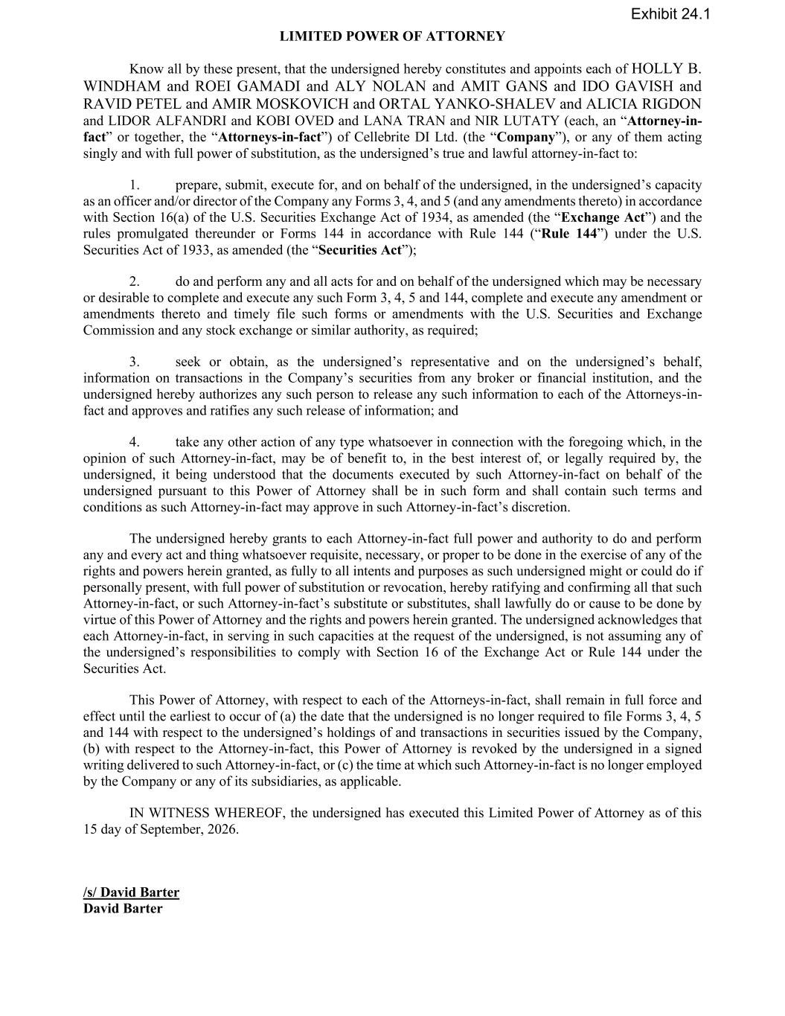
LIMITED POWER OF ATTORNEY Know all by these present, that the undersigned hereby constitutes and appoints each of HOLLY B. WINDHAM and ROEI GAMADI and ALY NOLAN and AMIT GANS and IDO GAVISH and RAVID PETEL and AMIR MOSKOVICH and ORTAL YANKO-SHALEV and ALICIA RIGDON and LIDOR ALFANDRI and KOBI OVED and LANA TRAN and NIR LUTATY (each, an “Attorney-in- fact” or together, the “Attorneys-in-fact”) of Cellebrite DI Ltd. (the “Company”), or any of them acting singly and with full power of substitution, as the undersigned’s true and lawful attorney-in-fact to: 1. prepare, submit, execute for, and on behalf of the undersigned, in the undersigned’s capacity as an officer and/or director of the Company any Forms 3, 4, and 5 (and any amendments thereto) in accordance with Section 16(a) of the U.S. Securities Exchange Act of 1934, as amended (the “Exchange Act”) and the rules promulgated thereunder or Forms 144 in accordance with Rule 144 (“Rule 144”) under the U.S. Securities Act of 1933, as amended (the “Securities Act”); 2. do and perform any and all acts for and on behalf of the undersigned which may be necessary or desirable to complete and execute any such Form 3, 4, 5 and 144, complete and execute any amendment or amendments thereto and timely file such forms or amendments with the U.S. Securities and Exchange Commission and any stock exchange or similar authority, as required; 3. seek or obtain, as the undersigned’s representative and on the undersigned’s behalf, information on transactions in the Company’s securities from any broker or financial institution, and the undersigned hereby authorizes any such person to release any such information to each of the Attorneys-in- fact and approves and ratifies any such release of information; and 4. take any other action of any type whatsoever in connection with the foregoing which, in the opinion of such Attorney-in-fact, may be of benefit to, in the best interest of, or legally required by, the undersigned, it being understood that the documents executed by such Attorney-in-fact on behalf of the undersigned pursuant to this Power of Attorney shall be in such form and shall contain such terms and conditions as such Attorney-in-fact may approve in such Attorney-in-fact’s discretion. The undersigned hereby grants to each Attorney-in-fact full power and authority to do and perform any and every act and thing whatsoever requisite, necessary, or proper to be done in the exercise of any of the rights and powers herein granted, as fully to all intents and purposes as such undersigned might or could do if personally present, with full power of substitution or revocation, hereby ratifying and confirming all that such Attorney-in-fact, or such Attorney-in-fact’s substitute or substitutes, shall lawfully do or cause to be done by virtue of this Power of Attorney and the rights and powers herein granted. The undersigned acknowledges that each Attorney-in-fact, in serving in such capacities at the request of the undersigned, is not assuming any of the undersigned’s responsibilities to comply with Section 16 of the Exchange Act or Rule 144 under the Securities Act. This Power of Attorney, with respect to each of the Attorneys-in-fact, shall remain in full force and effect until the earliest to occur of (a) the date that the undersigned is no longer required to file Forms 3, 4, 5 and 144 with respect to the undersigned’s holdings of and transactions in securities issued by the Company, (b) with respect to the Attorney-in-fact, this Power of Attorney is revoked by the undersigned in a signed writing delivered to such Attorney-in-fact, or (c) the time at which such Attorney-in-fact is no longer employed by the Company or any of its subsidiaries, as applicable. IN WITNESS WHEREOF, the undersigned has executed this Limited Power of Attorney as of this 15 day of September, 2026. /s/ David Barter David Barter Exhibit 24.1

